**POWER SUPPLY SUBSYSTEM**

The one thing to remember about battery selection is that there is no such thing as a perfect battery that works for every application. Selecting the right battery for our application is about identifying the most important battery metrics and trading these off against others.

For this selection, we use the comparisons in Figure x.

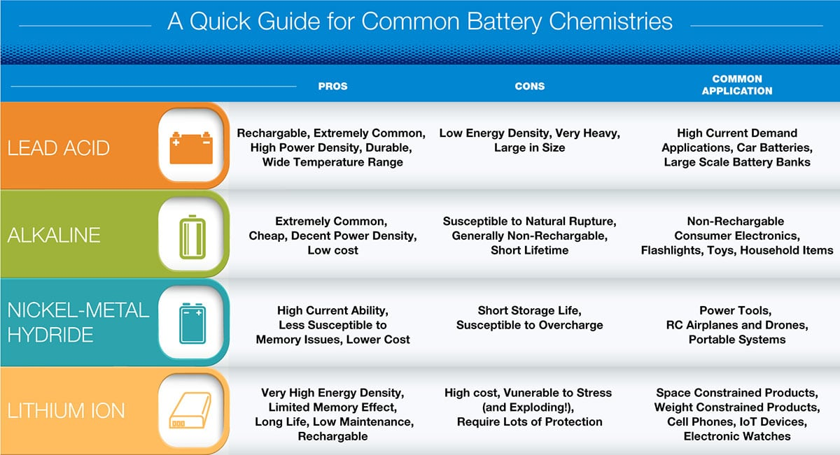

Figure 1:Quick Guide for Common Battery Chemistries [1]

Lithium is the lightest metal in the periodic table and has a specific capacity of 3860 mAh/g. Lithium also has an electrochemical reduction potential of 3.045 V against 1.22 V for NiMH (i.e a lithium based battery provides a battery voltage of 3 V or greater). Some of them can be seen in Figure x+1. The combination of these two properties results in very high energy densities for lithium based batteries.[4]

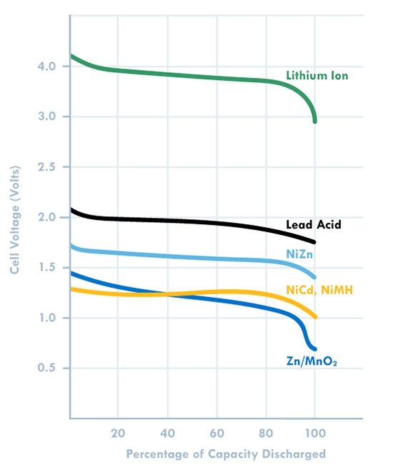

Figure 2: Graph of one cell voltage capacity [2]

Li-Po batteries are lightweight, can be produced in desired size, have high capacity and power, also have fast charging and discharging features provides us to choose the Lipo battery.

We decided to use Li-Po to drive motor, but we decided to use powerbank for controllers (arduino, raspberry). Because they have to drive with 5V. For this reason, we can also use a voltage regulator with a Li-Po battery for controllers as a backup plan.

After deciding to use Li-Po, the next step was to choose which type of Li-Po should be used. Since we need 12V, we decided to use "3S" (3 * 3.7V = 11.1V. In Figure x, the one Li-Po cell can be seen.

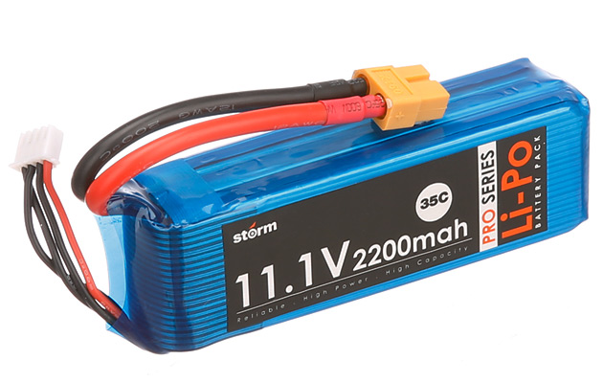

Figure 3: Example of 3 cells Li-Po Pack [3]

The power sources that we should use in the project can be seen below.

**Robot Part:**  Drone Transmitter LiPo – 12V

2 DC motors for movement LiPo – 12V

1 DC motor for shooting LiPo – 12V

Arduino Mega Powerbank – 5V

Radio Li-ion (inside itself)

**Controller Part:** Drone Receiver LiPo – 12V

Raspberry Pi 3 Powerbank – 5V

## Level Risks Assessment

There are few risks of using the above-mentioned processors.

* The first risk is these systems heats a lot which can create a risk for other parts of the system.
* Pwer supplies are one of the heaviest part of our whole system, so they can create alignment problems and cause immobilize .

## Error Sources

Some internal and external sources can cause an error at this subsystem. The possible error sources are as follows:

* Environmental temperature conditions can be a source of error. To eliminate this effect fan can be used or power is drawing can be reduced.

REFERENCES

[1]: <https://static4.arrow.com/-/media/arrow/images/miscellaneous/0/0717-battery-chemistry-comparison-chart.jpg?la=en&hash=5A3A6E8E9C68043D70609CF0C583A3C8522A397B>

[2]: <https://www.dfrsolutions.com/blog/how-to-select-the-right-battery-for-your-application-part-1-battery-metric-considerations>

[3]: http://www.helipal.com/storm-11-1v-2200mah-35c-pro-series-li-po-battery-xt60.html

[4] Wendt, Z. (2017, December 26). 5 Essential Factors for Choosing the Right Battery. Retrieved from https://www.arrow.com/en/research-and-events/articles/choosing-the-right-battery-for-your-internet-of-things-application